AFFIX PHOTO
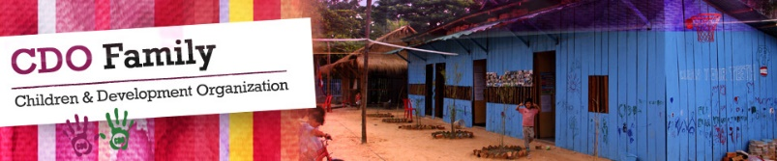

Children and Development Organization (CDO)
Volunteer Agreement
This form must be completed before volunteering to meet the organization’s required conditions.
Volunteers must:
- Read and comply with our Child Protection Policy (available on website)
- Affix a passport photo to this application, scan and attach to email.
- Agree to be supervised by a coordinator appointed by CDO.
- Seek permission before taking or publishing photos of the children.
NOTE: Children must be adequately clothed in photos taken of them and in poses that are not sexually suggestive.
Refrain from giving gifts to individual children.
- Dress modestly and wear a CDO t-shirt and shorts/skirts of an appropriate length at all times. Cambodia is a very conservative country and CDO is subject to police checks.
- FEES: CDO charges $85 for people to volunteer – preferably for a minimum of 20 days (Monday to Friday). You will be supplied with a CDO t-shirt (inclusive of price) that should be worn when volunteering. Extra t-shirts $15. The balance of the money will be used to support projects, such as a library and further education sponsorship programs. This money can be paid by bank transfer (see website) or cash on arrival. A receipt will be supplied. Special arrangements can be made, at the Director’s discretion, for service and voluntary support groups.
Drugs and alcohol are NOT prohibited on the premises
Volunteer details
I have read and understood the information above and accept the terms and conditions.

Name:__________________________________________
Address:________________________________________
________________________________________
Date of birth: ___ / ___ /___ Sex: ________
Nationality:_____________________________
Age:___________________________________
Male/female (circle)
Passport Number:________________________
Email:__________________________________________________________ (PLEASE PRINT CLEARLY)
Start date:___ /___ /___ Finish date: ___ / ___ /___
Please circle your areas of expertise: Education and teaching (please indicate language ________________ ) /childcare/medical/agricultural development/healthcare/clean water supplies and access/environmental conservation and biodiversity protection/vocational training/community support/social work/IT/web design/graphic design/photography/marketing/administrative/curricular development.
Qualifications:________________________________________________________________________
Do you have a criminal record: Yes/No
If Yes, please provide details:____________________________________________________________
SUPPLY A CURRENT POLICE CHECK FROM YOUR COUNTRY OF ORIGIN - SCAN AND ATTACH TO APPLICATION
______________________________________________________________________________
Thank you for your cooperation. We hope your experience as a volunteer is rewarding.
CDO management

Email your application to:
Info.cdocambodia@gmail.com
Send $US85 to:

Acc Name: Children & Development Organization
Swift Code: ACLBKHPP
Acc No.: 0100-20-940585-1-5
OR
Pay cash on arrival

